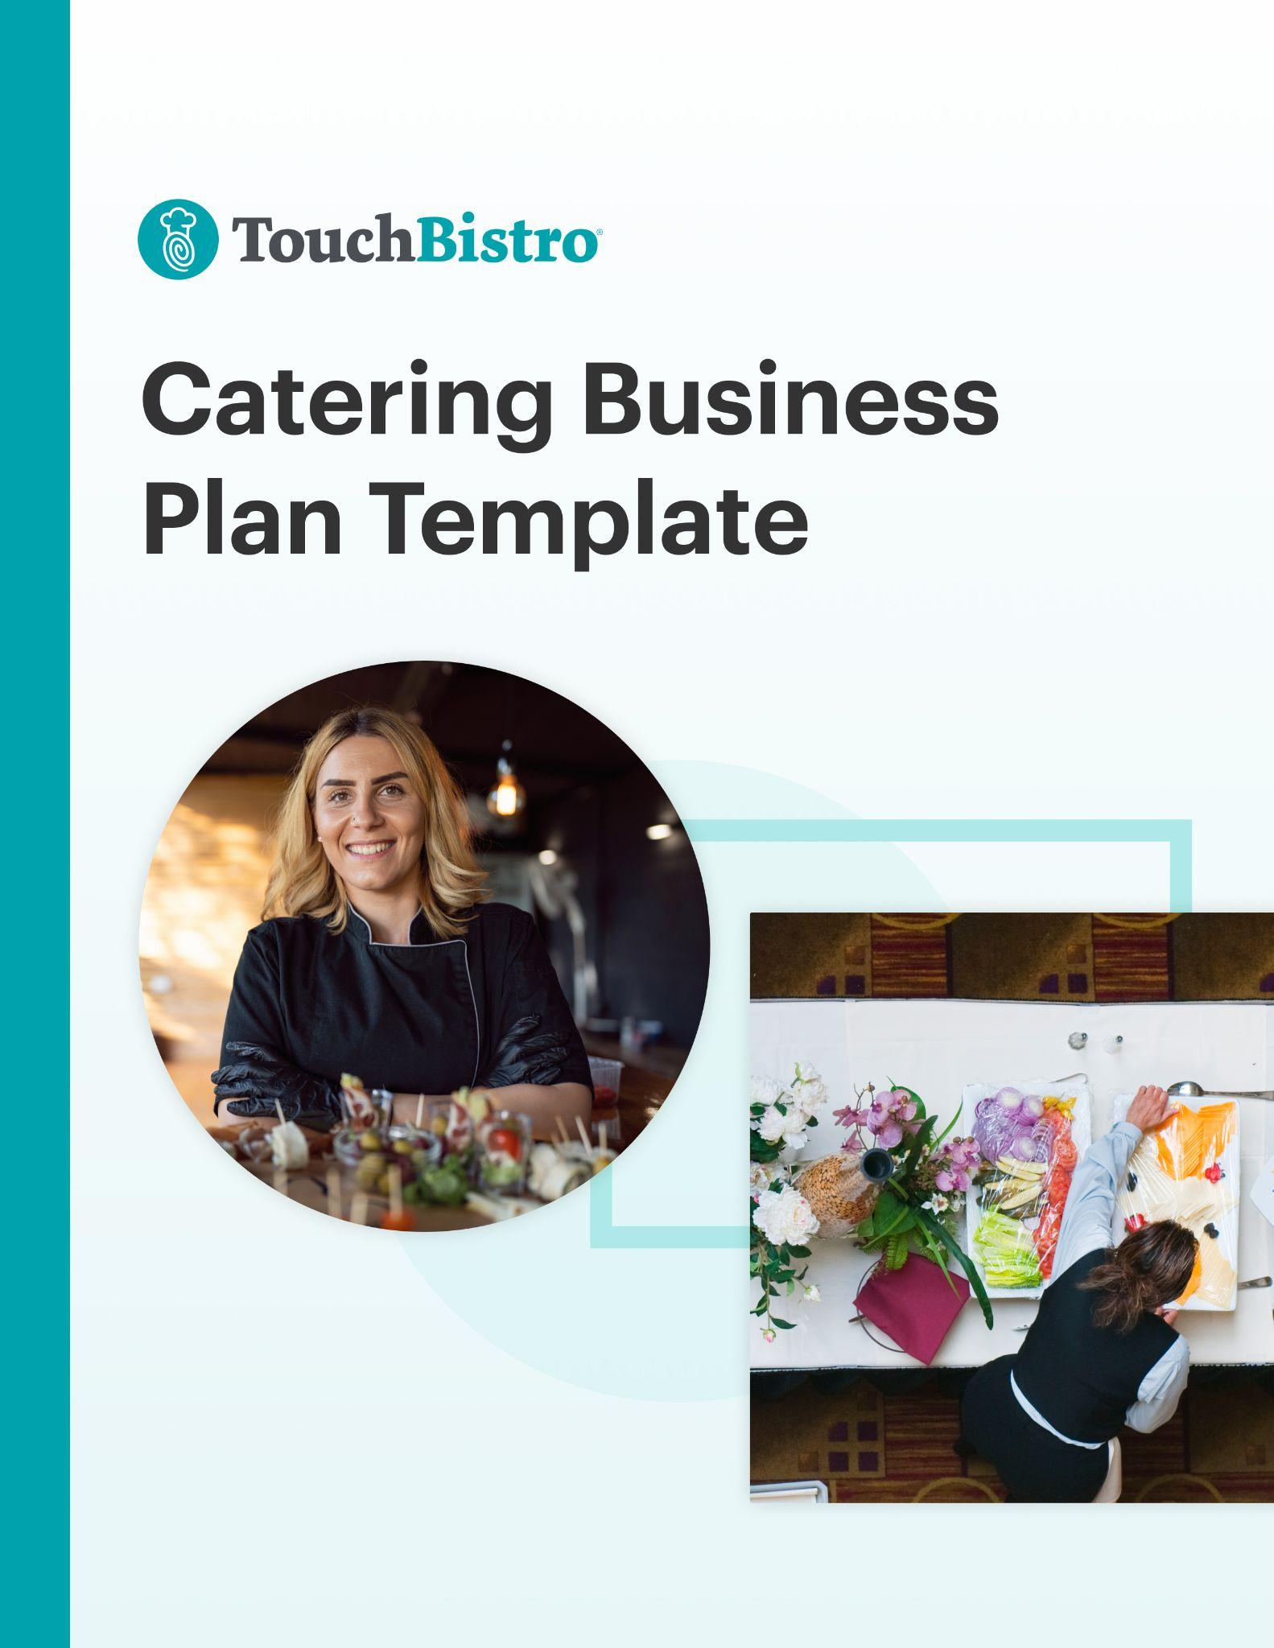

Thank you for downloading TouchBistro’s Catering Business Plan Template!

This catering business plan template will help you outline the vision for your new business and share that vision with your investors.



Instructions
This catering business plan is designed to be fully customized. Under each header, you’ll notice a description for the section in red italics. To customize each section, simply delete the red text and add your own information.

Once you’ve finished filling in each section, delete any remaining red text, as well as the cover page and this instructional page.

To print your template: Click File > Print
To save the template as a PDF: Click File > Save As > PDF

[YOUR COMPANY LOGO]

Business Plan for [NAME OF CATERING COMPANY]

ADDRESS
PHONE NUMBER
WEBSITE
EMAIL

Table of Contents

Here you’ll find the outline for each section of your catering business plan. You can adjust the table of contents as you customize each subsection of your business plan.

Executive Summary

Company Overview

Market Analysis

Business Offerings and Menu

Operations Plan

Marketing and PR Plan

Financial Analysis and Projections

Appendix

Executive Summary

A catering business plan should always start with an executive summary. This section should summarize your main points, while also inviting the reader (often an investor) to read the rest of your business plan.

The executive summary should also highlight key elements that will be discussed throughout the rest of your business plan, such as:

Business Overview
- Your catering company’s name, concept, and menu items: For example, “Plant Powered Catering is a plant-based catering company in Portland, Oregon specializing in vegetarian and vegan catering for weddings.”
- Your mission statement and guiding principles.
- Your location and service area: Explain if you have operations in more than one city, and identify your service area radius (i.e., whether you only cater events in your city or town, or outside municipal limits). Include whether your kitchen is open to the public for meetings and tastings, if it is by appointment only, etc.
- Your catering service model: Discuss what types of events you will serve. For instance, corporate events, weddings, and backyard parties. Include the kinds of venues you will serve, such as meeting facilities without kitchens and clients’ homes. Also, specify the size of events you will cater.
- Your target market: For example, “We are a B2C catering company. Our target client is a bride-to-be who desires a farm-to-table menu at her small to medium-sized wedding.”
- Your unique menu: For instance, “We serve a wide selection of appetizers, entrees, and desserts primarily sourced from local suppliers in the Pacific Northwest. We are also licensed to serve liquor at our events.”
- Your kitchen’s ambiance, and/or the look and feel of your brand: If you have a public space for meetings and tastings, describe the atmosphere. For example, “Our catering headquarters is bright and welcoming. Guests receive a complimentary glass of champagne as they peruse our catering menu.” If you do not have a public space, emphasize the look and feel of your brand. “The Plant Powered Catering brand is brimming with vibrancy and vitality. We make plant-based catering fun and delicious.”
- Information on your management team: Mention the team’s experience, knowledge of the industry, and understanding of how to run the operational side of the business.

Success Factors
- Facility/lease information, capacity, transportation, and supplies: This includes important information about your kitchen and its capacity to prepare food for events of a particular size. It also includes information about your fleet of vehicles for transporting food, and whether you supply tables and chairs, etc., or tableware, food, and beverages only.
- Your market position and competitive advantage: Think of what makes your catering company stand out. For example, “Our market is lucrative and growing, and we are the only caterer in the Portland area to offer both vegetarian and vegan options.”
- Competitor information: Who offers a similar service to your company? How will you overcome the competition? For instance, “In addition to marketing our services to brides, we have strong relationships with wedding venues and planners who consistently promote our services for a referral fee.”
- Sales and marketing: How will you attract a steady flow of clients to your business to ensure its success and longevity? For example, “We have a strong presence at wedding trade shows in Portland and Seattle, as well as a focus on building a large, engaged social media following.”

Financial Highlights
- Your financial projections and break even point.
- What funds you need and how you plan to use them to achieve success.
- A summary of potential costs and the expected return on investments.

While it may be tempting to try to include a lot of information right off the bat, try to keep this section between 200 and 600 words.

Company Overview
This section is where you fully introduce your new business. The purpose is to provide your reader with a high-level overview of your catering company idea and to answer key questions investors may have about your business history, service type, and ownership structure.

As you fill out each of the sub-sections below, keep in mind that this part of your business plan can come across as a bit dry. Think about how you can make your idea stand out with compelling language and captivating details.

Concept
Provide a high-level overview of the concept for your new catering company. While you don’t need to go into too many specifics here, you may want to touch on:

- The defining theme for your company
- The food and beverages you plan to offer
- What kind of packages and price points you will sell

Company Information and History
Provide a summary of your catering company’s founding date, history, and why you opened it in the first place. You should also include important details like:

- Your contact phone number, email address, and mailing address.
- Your website and social media links.
- Banking details like your branch and banker’s name.
- Your company’s legal name and structure: You can operate as a sole proprietorship, partnership, cooperative, limited liability company, C Corporation, or S corporation.
- Founding team members: You can mention your team’s experience with catering and how they have made a name for themselves in the industry.
- Milestones to date: Write about any goals you’ve hit, such as assembling your management team, launching your website, catering your first large event, or securing local press coverage.

Mission Statement
Your mission statement communicates what your catering company stands for and what you’re trying to achieve. When writing your mission statement, consider your end goals. For example, “to help our clients elevate their events with delicious, healthy, and innovative cuisine, while providing an outstanding level of service.”

Business Objectives
Describe any short or long-term goals that you would want an investor to know about. For example, are you considering entering into new markets beyond your current target reach? Remember to be concise, and to keep your objectives reasonable and achievable.

Clientele and Service Model
Explain what kind of catering service you will provide and why. For example:

- Corporate catering: This can include breakfasts, lunches, dinners, board meetings, or networking happy hours. Or, larger events like conferences and tradeshows.
- Weddings: Common types of wedding catering include reception service, and sit-down dinners or buffets after the main event takes place.
- Social events: This can include birthday parties, retirement parties, and more. Sporting events and concerts could also fall into this category.
- Full service: When you offer full service, you’re likely supplying both food and beverages, including alcohol; and preparing and transporting all food and supplies, potentially including tables, chairs, buffetware, and tableware. You’re serving the food and may even have a bartender. You’re also taking care of both setup and teardown.
- Drop-off service: With this option, you’re simply preparing and dropping off the food, as well as possibly setting up tables. Food service is not included.

Market Analysis

This section is where you describe the specific location and service area radius of your new catering company, as well as the current market conditions. In addition to general information about your market, explain your unique positioning, the target audience you’re hoping to appeal to, and how you’ll make your catering business stand out.

Location
Provide the location of your business and why you chose that specific area. If you have not yet chosen a location, describe the area you plan to operate in. For example, mention if your catering company is located in a popular wedding destination like Napa Valley, California, or Aspen, Colorado.

If you are one of many catering companies in a location, point out what makes you different, such as the ingredients you use or the style of service you offer.

Target Market
Describe your target market and your ideal customer profile. Include key information such as market size, demographics, characteristics, and behaviors. If you performed any market research before starting your catering company, make sure to include that too. For example, if there is a thriving business community in your area, the sales potential for specializing in corporate event catering could be promising.

Market Positioning and Strategy
Explain how you’ll reach your target audience. Outline how you’ll position your brand and how you’d like it to be perceived by clients.

Competitive Analysis
Outline the current competitive landscape, as well as your own competitive advantage.

It’s more than likely that there are other catering companies in your area targeting the same demographics, which means you’ll need to explain how you’ll stand out from the competition. The best way to do this is to include a SWOT analysis for your business that outlines its strengths and weaknesses, as well as any external opportunities and threats. This will help investors better understand the specific aspects of your operation that will give you a competitive advantage over similar concepts in the area.

Here is a simple example of what your SWOT analysis could look like:
Strengths:
An award-winning chef, and a leadership team with 20 years of catering experience.
Weaknesses:
The ramp-up time for new staff could set financial projections back.
Opportunities:
Plant-based catering is growing in popularity across the U.S., with Portland being one of the top cities where it’s most in-demand.
Threats:
An established catering company in the city also offers plant-based options (although not exclusively), which may take away some of our market share.

In your SWOT analysis, remember to not only identify weaknesses and threats, but also how you can overcome them. You want to reassure investors that your business will succeed despite the challenges you’ll face.

Business Offerings and Menu

This section focuses on the type of catering you will offer. Discuss every detail about what you plan to sell – whether that’s appetizers, entrees, desserts, alcohol, or all of the above and more. Make sure to provide an explanation for why you have chosen this approach, and how your catering menu will appeal to your target market.

Remember to avoid industry jargon, buzzwords, or technical knowledge, so someone unfamiliar with your catering concept will understand what you’re trying to achieve and get excited about your offerings.

Business Offerings
What types of offerings will you be bringing to the market? Here are a few questions to consider to help you come up with a clear answer:

- Will you be reinventing recipes, or creating brand-new menu items?
- Will you include specialty items like gluten-free or custom-made products?
- Where will you source and buy your ingredients and equipment from?
- Will you be selling a one-size-fits-all catering service or offering different packages?
- How do your catering offerings compare to others currently on the market?

Sample Menu
Include a sample menu for your catering company. This section should also outline your strategy for menu pricing. Here are a few tips:

- Write about the type of food that sets you apart. For example, “We go beyond typical finger food to offer a creative and memorable catering experience. Here are some of our most innovative items…”
- Explain why you are serving certain food and drinks to your target market. For example, “With interest in farm-to-table dining on the rise, we are filling a gap in our local market. In addition to traditional alcoholic beverages, we also offer delicious mocktails to cater to the growing market that chooses not to drink alcohol.”

Operations Plan

This section covers how your catering company will operate day-to-day once you’re up and running. It should touch on key aspects of your business operations, including your staffing strategies, the technologies and equipment you plan to use, labor and workflows, and suppliers.

Staffing and Training
Staffing is a major hurdle for just about every hospitality business. This is why it’s critical to provide your reader with a breakdown of your staffing strategy, including how you plan to recruit new staff and the hiring criteria for each role. You should also share details about how many people you expect to hire for each role and the approximate pay for each position. For example, will you hire additional caterers during peak seasons? Will you hire a staff member to oversee administration and client meetings at your headquarters?

This section should also touch on day-to-day staff management, including how you will handle scheduling, payroll, and labor reporting. If you are hiring a manager to oversee payroll and human resources, be sure to mention this in your Operations Plan. You may also want to include details about staff training procedures and work safety standards.

Technology and Equipment
Technology can offer your catering company many operational advantages. In this section, provide an overview of the technology you’ll use in your business, such as inventory management software, an online ordering system, and more. You should also mention key pieces of specialized equipment you plan to use.

Here are some examples of what to include in this section:

- Commercial catering van
- Insulated food pan carriers to keep meals hot
- Serving trays and utensils
- Technology such as a mobile catering point of sale (POS) system to process transactions

Kitchen Layout and Workflow (On and Off-Site)
Here, outline how your kitchen functions, including your food preparation workflow and any customer-facing aspects of your on-site business, such as menu tastings. In addition, detail your off-site workflow – from setup to teardown – for the events you cater. This can include a sample floor plan showing how you lay out various food and beverage stations at events, which you can insert here and/or attach in the appendix.

Remember to include key functions in your workflow such as:

- Order fulfillment processes: This covers all of your activities involved from the moment a client books you to cater their event, until after the event has concluded.
- Customer service strategies: These are everyday practices for interacting with customers, including how you conduct catering consultations and menu tastings, as well as how you deliver outstanding service at the events you cater.
- Cleaning and maintenance practices: This is how you keep your catering kitchen clean. For example, by mentioning how you keep the space organized and clutter-free, and how often you clean your equipment. You should also include how you keep your catering vehicle clean, since you’ll be using it to transport food.

Inventory and Suppliers
Describe the operational processes you adhere to, such as your food cost control methods and inventory suppliers. Provide an overview of the type of vendors you’ll use and how you’ll manage inventory as well as ingredient costs. If applicable, include the cost of using various food and drink vendors.

Here are some categories to help you come up with a list of vendors and suppliers:

- Products: This category includes the ingredients you will use to make the appetizers, entrees, and desserts on your catering menu. For example, you may choose to source grass-fed beef or organic vegetables from a local farm.
- Equipment: This category may include dinnerware, tablecloths, or even tables and chairs if you provide those items to your catering clients. Additional equipment may include chafing dishes or outdoor coolers. You will also need a cash drawer to pair with your POS, which will keep track of sales and inventory.
- Additional supplies: Think of the supplies you’ll need not only to cater events, but also for your on-site operations. For example, if you plan to display sample items from your menu at your catering headquarters, then you will need display cases.

Insurance and Licenses
Include your insurance provider and plan information. This will show your reader that you’re proactive about mitigating risk in the case of an unexpected injury or equipment failure.

List any business licenses or other permits that you have attained. For more information, ask your local government about required licenses and permits in your location.

Marketing and PR Plan

This section outlines the marketing strategies and tactics you’ll employ to get the word out about your catering company. Be sure to go into detail about how you plan to market your business, both before and after you open. Here are a few aspects you should cover:

Market Positioning
Discuss how you will position your catering company’s brand so that it will be top of mind for your target market. Call out any key differentiators, like what clients can get from your business that they can’t get elsewhere. To figure out your differentiators, ask yourself a few questions:

- What type of catering do you specialize in?
- What kind of client experience do you offer?
- What makes your catering service unique?

Pricing Strategy
Describe how your pricing compares to competitors. Here are a few questions to answer:

- What are your costs? Consider ingredients, equipment, and labor.
- What is the market price for similar catering services?
- How does your pricing measure up to the market price?

Remember that your pricing strategy needs to cover the costs of both food production and catering the events themselves, and leave room for profit so you can grow your business!

Location Strategy
For this section, explain how your location will impact your catering company’s success. For example, do you plan to market mostly to a local audience, or will tourism to your city or town (i.e. destination weddings and corporate event travel) play a role in driving business for you?

Promotion Strategy
Your promotion strategy refers to the plan and tactics you will use to increase demand for your catering. It can include the following elements:

Public Relations
Whether you plan to hire a PR firm or take care of publicity yourself, you’ll want to map out a PR strategy for your catering company. Include which media outlets you plan to target – for example, business magazines or wedding podcasts, depending on your catering company’s clientele. Also include sample materials you may send to relevant publications, such as a press release about your catering company launch or VIP invitations to a launch party.

Advertising
Advertising can help your catering company reach a broader audience. This part of your plan can include digital advertising channels such as paid search ads on Google, or Facebook, Instagram, and Pinterest ads. It can also encompass more traditional advertising tactics like flyers and radio ads, which can work well for local audiences.

Social Media
These days, nearly every catering company leverages social media for marketing. Your plan should explain how you will use social media to reach your target audience, including which platforms you’ll use (for instance, Pinterest for targeting brides-to-be or LinkedIn for targeting corporate catering clients), what kind of content you’ll share, and how you’ll build a digital community around your business.

Your Website
Ensure that your website uses search engine optimization (SEO) tactics so your content will show up in keyword searches on Google. Consider starting a blog to boost your SEO further. Whether you have a blog or not, the content on your catering company’s website should be useful to your target market, and your catering menu and package options should be easy to find from your home page.

Email Marketing
Building an email list provides you with a direct line of communication to current and potential clients. You can use PR, ads, social media, and your website to encourage your target market to sign up for your email list. Try offering an incentive like a discount on catering for those who join. As your list grows, nurture it with regular email marketing so your audience will be up-to-date on your services and engaged with your brand.

Community Partnerships and Referrals
No catering company operates in a vacuum. This part of your plan should explain any partnerships you plan to strike up with influencers or community organizations, in addition to charitable initiatives. Also mention whether you plan to spread the word by asking previous catering clients or event planners to leave a review of your services.

Free Samples
Include whether you plan to host a tasting event as part of your launch strategy, where you’ll offer free samples from your catering menu to let people taste the quality of your culinary creations and learn more about what you offer.

Financial Forecast and Expenses

Although your financial analysis is one of the last sections in your catering business plan, it’s also one of the most important. In fact, many investors skip straight to this section to see a breakdown of your anticipated costs and projected revenue, as well as how you plan to allocate their investment.

Catering companies tend to have relatively low profit margins of 7-8% on average, so this section must emphasize how your business will grow and be profitable in the long term.

Before finalizing this section, triple-check your projections and consider hiring a financial professional to make sure your numbers are sound.

Startup Costs
Disclose how much money you’ll need to get your catering company off the ground, including your biggest expenses. High-ticket items will typically include your catering vehicle and kitchen equipment, as well as a stockpile of tables and chairs for events, if you choose to provide them.

Financing and Loans
Many caterers require loans or other sources of funding to get up and running. In this section, detail the types of financing or loans you’ll need to fuel your growth. This will vary based on factors like whether you have a public storefront where potential clients can visit you for menu tastings, and how many geographical areas you plan to serve.

Investment Plan
Here, explain the initial investment you are hoping to receive and how you plan to spend it during your first year in business. For example, how much money are you planning to allocate toward staffing, operations (including food costs), and marketing respectively?

Sales Forecast
Your sales forecast should highlight your projected weekly, monthly, and/or annual first-year sales projections. To get this number, you may use different criteria, such as the number of events catered per month, event capacity limits, catering package prices, and more.

Projected Profit and Loss Statement
Use a projected (or pro forma) profit and loss statement to show how much money you expect your catering company to have made (or lost) by the end of your first year in business. This figure should be based on your sales forecast, as well as your projected costs.

Break-Even Analysis
A break-even calculation reveals the amount of revenue needed in order for your catering company to make a profit. You can then compare this number to your sales forecast to determine how long it will take for you to break even, so you can let your investors know when they can expect to start seeing a return on their investment. This takes into account your fixed costs, like payroll, food costs, and catering vehicle-related costs.

Expected Cash Flow
Cash flow refers to the amount of cash that’s coming in and going out of your business. For a catering company, this figure will vary based on how often you expect to purchase inventory, the size of your staff, your payroll schedule, and other factors like the seasonality of your business, which is especially relevant for wedding caterers. Detail your expected cash inflows and outflows for an upcoming period (usually a year).

Include projected cash flow statements for all of your equipment, catering supplies, and labor. Consider costs for maintaining your vehicle and kitchen equipment, sourcing ingredients, hiring new employees or staffing up for peak seasons, etc. Investors want to know you can handle cash, so try to be thorough with monthly projections to prove you will be able to avoid credit risk.

To keep track of financial information more accurately, you can use accounting software that integrates directly with your POS such as MarginEdge, Xero, Sage, QuickBooks, or Shogo.

Appendix

Last but not least is your catering business plan appendix. While this section is optional, it’s a great place to include charts, plans, graphics, pictures, or any other material investors may find useful. In your appendix, you may want to include:
- Additional financial charts and figures
- Design mockups of your logo, branding, and/or catering vehicle wrap
- Mockups of your catering uniforms
- Photos of events you’ve catered, including the food stations and table settings

