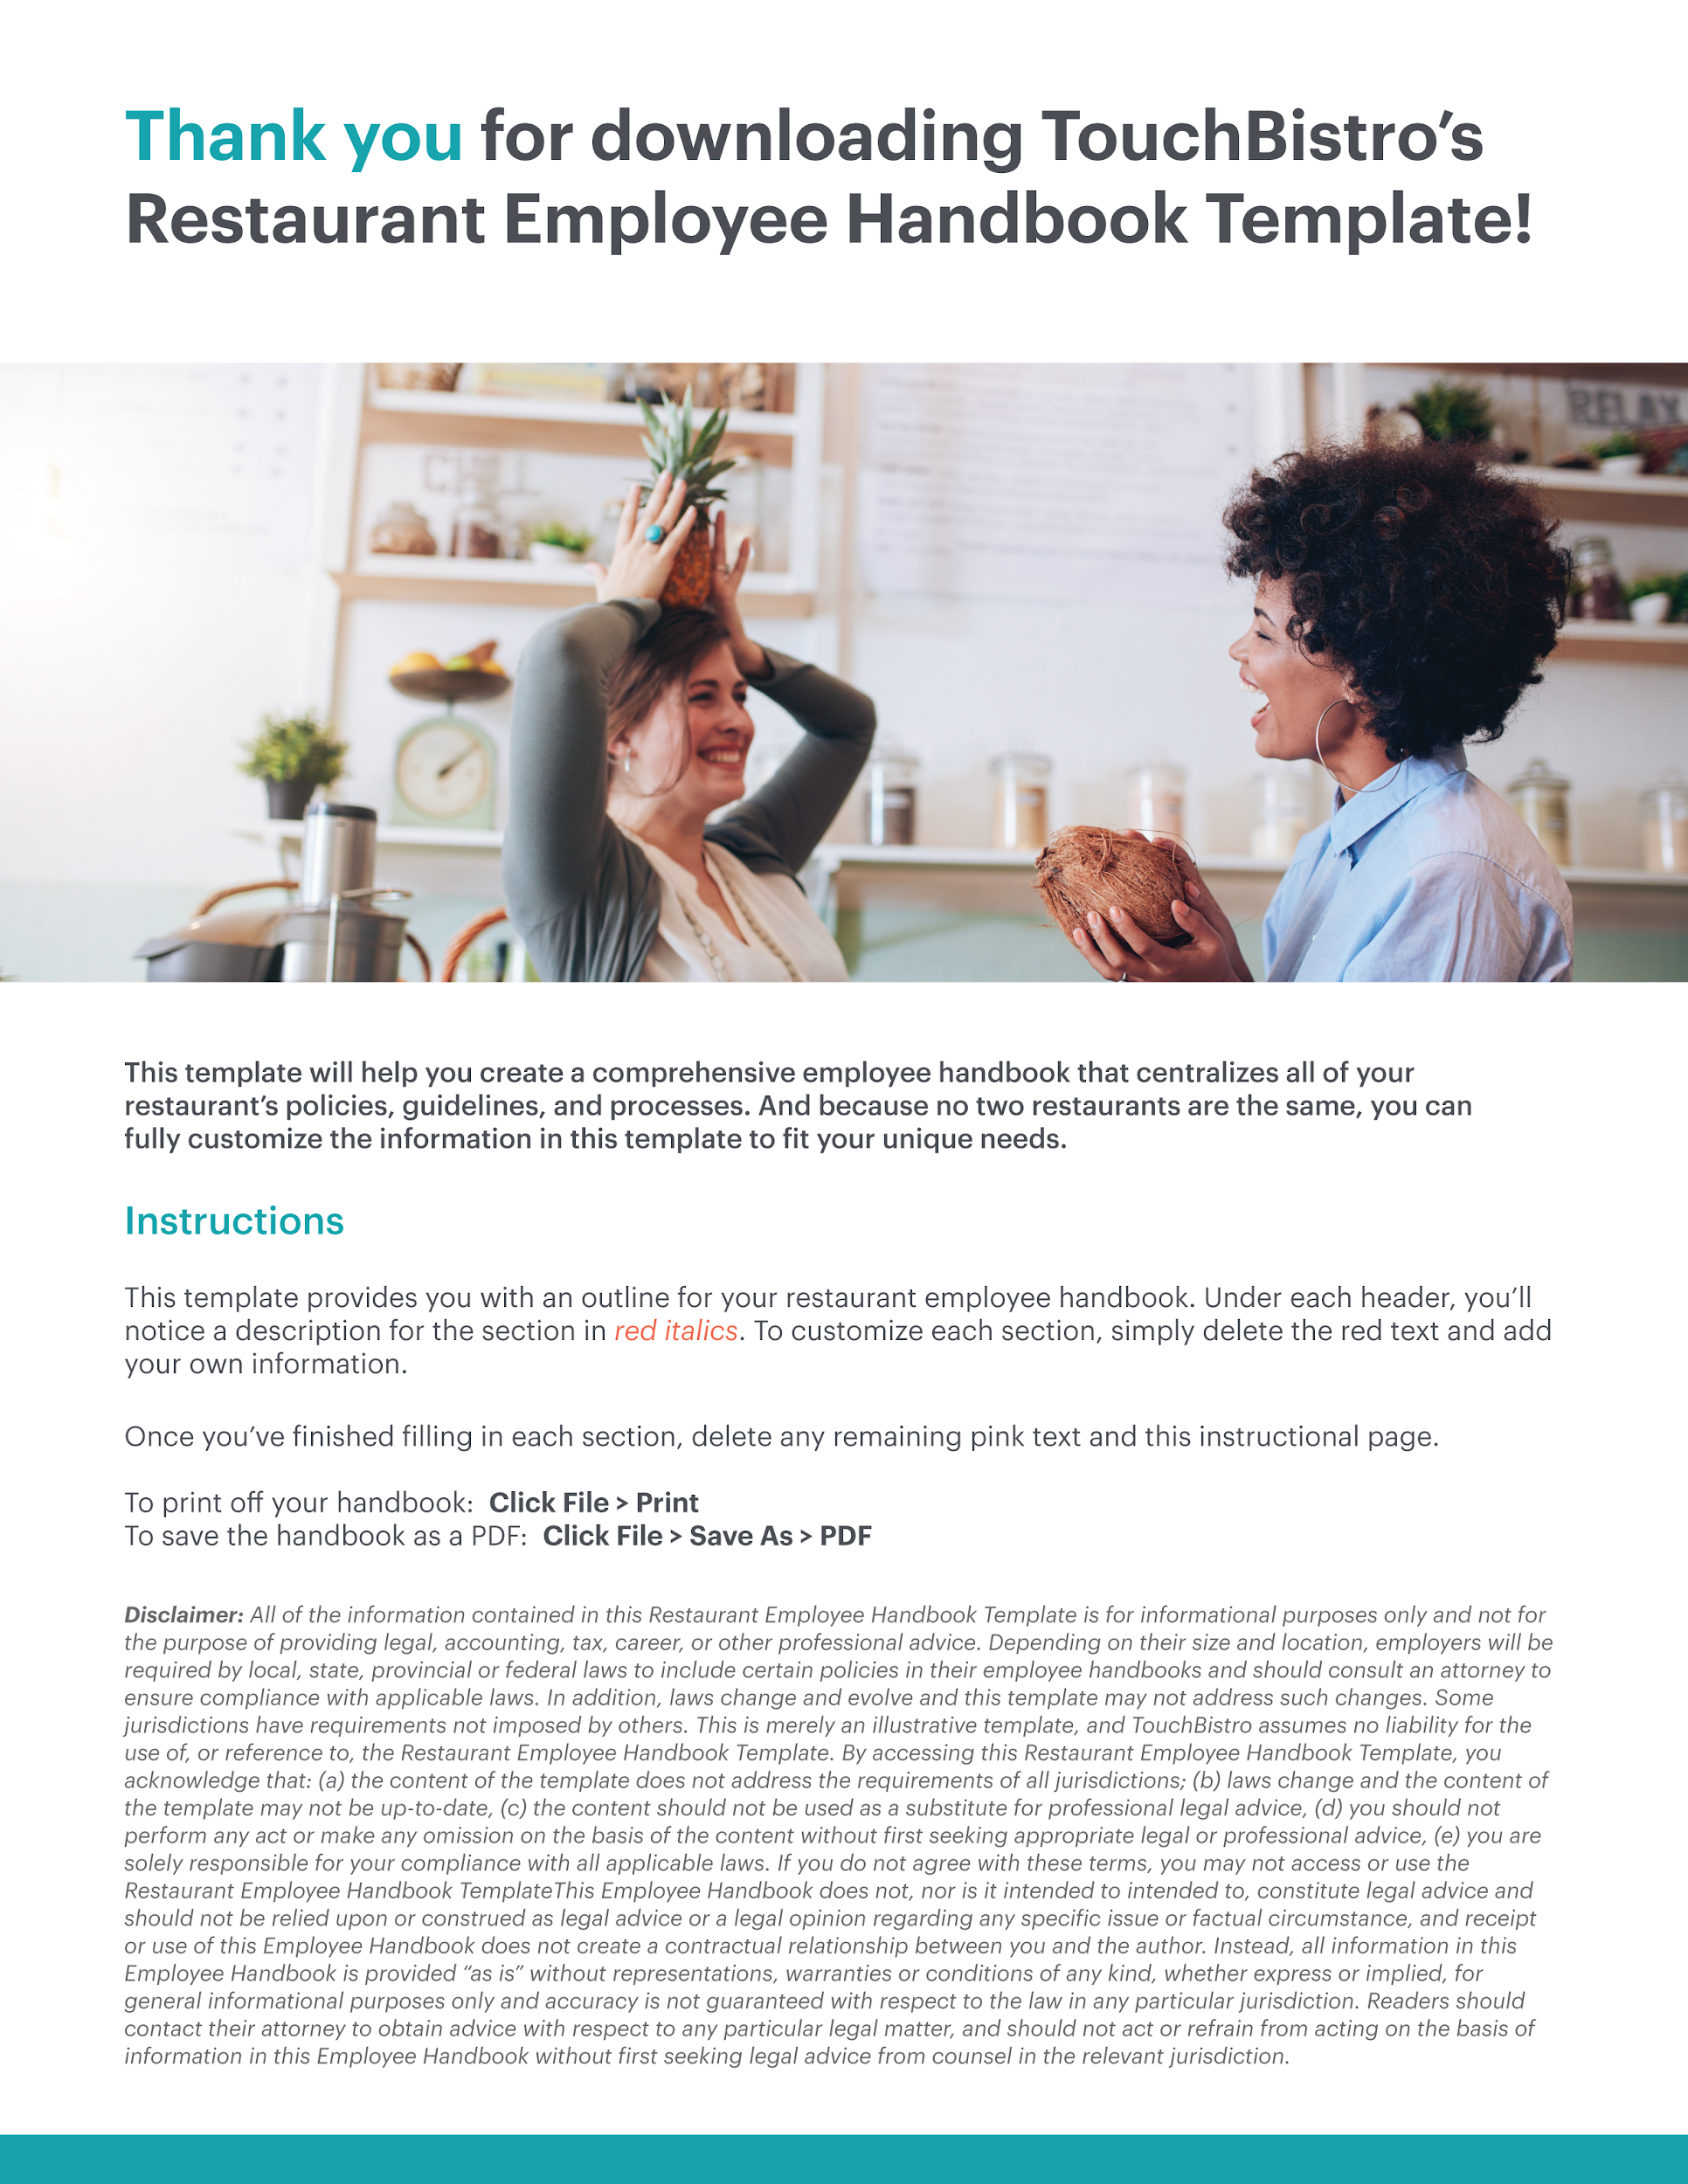

[COMPANY LOGO]

[NAME OF RESTAURANT] OFFICIAL EMPLOYEE HANDBOOK

RESTAURANT NAME
ADDRESS
PHONE NUMBER
EMAIL

Table of Contents
Here you’ll find the outline for each section of your restaurant employee handbook. Adjust the table of contents as you customize subsections of your handbook.

1. Introduction
Welcome Letter
Company Overview
Disclaimer
Confidentiality

2. Mission Statement and Core Values
Company Mission Statement
Core Values

3. Code of Conduct and Workplace Behavior
Dress Code
Smoking
Alcohol and Drugs
Weapons Policy
Cell Phones
Social Media
Customer Service
Disciplinary Procedures

4. Procedures and Emergencies
Scheduling Process
Attendance Expectations
Timekeeping Procedures
Meetings
Opening and Closing
Requesting Time Off
Missed Shifts
Serving Alcohol
Comps and Voids
Side Work
Safety and Sanitation
Reporting of Workplace Injuries
Emergencies
Theft and Robbery
Health Procedures and Allergy Protocol

5. Employee Compensation and Benefits
Pay
Tips
Payroll Deductions
Overtime
Holidays and Vacation
Breaks
Employee Meals and Discounts
Benefits and Insurance
Workers’ Compensation

6. Employment Policies
Equal Employment Opportunity Statement
At-Will Employment
Accommodations for Persons with Disabilities
Leaves of Absence
Family and Medical Leave
Personnel Files

7. Anti-Harassment and Complaint Procedure
Anti-Harassment and Anti-Discrimination Policies
Actions Constituting Harassment
Reporting Harassment
Actions Following a Harassment Report
Non-Fraternization Policy

8. Restaurant System FAQs
POS System
Kitchen Display System
Online Ordering Apps
Reservations Management Platform
Payment Processing
Scheduling Software

9. Conclusion
Conclusion
Employee Signature

1. Introduction

Welcome Letter
This is your chance to get employees excited about joining your team. Write a personal welcome letter that conveys what a great place your restaurant is to work.

Company Overview
It’s story time! Tell the story of your company, from its roots to where it is today.

Disclaimer
A step you don’t want to skip. Consult an attorney to write a disclaimer that explains this handbook is not a legal contract. Without a disclaimer, a terminated employee could seek legal action for breach of contract.

Confidentiality
Make a note that information contained in your employee handbook, as well as other insider information, must be kept confidential.

2. Mission Statement and Core Values

Mission Statement
Add a mission statement that explains why your company exists and what you believe in – beyond serving great food.

EXAMPLE: Our mission is to create healthier communities by making whole foods accessible to everyone.

Core Values
List the values that matter to you most and connect to your restaurant’s mission.

EXAMPLE: Quality, Community, Sustainability, Teamwork, and Creativity

3. Code of Conduct and Workplace Behaviour
Use this section to outline your expectations for employee behavior, covering everything from the dress code to safety procedures. Though it’s easy to focus on the negatives, you don’t want to scare your employees! Explain that these are simply guardrails and employees who stay between them will do just fine.

Dress Code
Here you should cover anything and everything related to your dress code, including clothing, shoes, haircuts, facial hair, tattoos, piercings, makeup, and more. When writing these guidelines think about safety and your brand identity while making sure to accommodate for all religious beliefs, racial differences, and gender expressions.

If your restaurant has uniforms, use this section to answer any questions about uniform requirements and expectations.

Smoking
Smoking is prohibited indoors, but the distance between designated smoking areas and public entrances varies by state. Check with an attorney to make sure your smoking policy is in line with your local laws. This section should also address the use of e-cigarettes and vapes.

Alcohol and Drugs
Make sure your policy is crystal clear about bringing alcohol or drugs into the workplace and include the consequences of breaking these rules

You should also address the issue of drinking or using substances while on the job, before a shift, and after a shift. If you don’t want employees socializing after hours in your restaurant, make your policy clear.

Weapons Policy
Apart from state laws, there are a myriad of reasons you may want to prohibit employees from bringing weapons on to work premises. This section should clearly state your policy on bringing weapons to work.

Cell Phones
Whether you have a strict no-phones policy or you’re a little more lax, explain when and where your employees can use their phones.

Social Media
Not all press is good press. Create social media guidelines for employees, including the use of your restaurant’s name, photos of the workplace, and rules around any mention of guests or other staff.

Customer Service
Outline your customer service standards. This can include everything from specific phrases employees should use on the phone to how to handle customer complaints.

Disciplinary Procedures
List behaviors that would be considered unacceptable in your restaurant. Use the phrase “including, but not limited to” so that employees know that the list is not exhaustive. Clearly explain the disciplinary action that will follow any unproductive or inappropriate behavior, but make sure you don’t instill undue fear in your employees.

4. Procedures and Emergencies
This section should help employees understand day-to-day operations and what to do when business-as-usual is interrupted, such as in the event of an emergency. Keep in mind that this section isn’t a substitute for hands-on training, so stick to need to know information only.

Scheduling Process
Outline your full scheduling process, including what software you use (if any), how the schedules are created, and when employees will receive their schedules. You should also address different scheduling scenarios such as your on-call policy.

Attendance Expectations
Explain when you expect staff to arrive for their shifts and your policy for repeated tardiness. For instance, you may want staff to arrive 10 minutes prior to their shift so that they can begin working as soon as their shift starts.

Timekeeping Procedures
For non-exempt employees, explain the timekeeping procedures for recording their time worked. For instance, if you utilize an electronic clock system, identify the system as the means for employees to record their time, explain that employees are responsible for accurately recording their time, and outline any potential penalties if the employees fail to accurately record their hours worked.

Meetings
Make sure staff understand how meetings are conducted in your restaurant and when they’re expected to arrive.

Opening and Closing
This is a good spot to include an opening and closing checklist for employees. Be sure to include notes about important tasks such as locking up the restaurant and closing out the POS system for the day.

Requesting Time Off
Let staff know how to request time off – whether it’s through software or in person. You should also explain how much notice they need to give when requesting time off and whether they are allowed to switch shifts with their colleagues.

Missed Shifts
Let employees know what to do, and who to notify, if they think they’ll miss their shift. You can also outline acceptable reasons for missing a shift, such as illness or a family emergency.

Comps and Voids
Explain who has the authority to authorize comps or void tabs, as well as how to do this in your restaurant POS.

Serving Alcohol
Explain which employees are authorized to serve alcohol and your guidelines for checking IDs. You’ll need to consult your local, state, and federal laws here to make sure that you’re in compliance.

Side Work
If you require employees to complete side work in addition to guest-directed services as a part of their responsibilities, outline that expectation here. Consider adding a brief statement as to why side work is important.

Safety and Sanitation
Explain proper cleaning procedures for front-of-house and back-of-house employees. This should cover rules around handwashing, glove-wearing, food serving, dishwashing, and more.

This section should also include proper safety guidelines for your restaurant in compliance with the laws outlined by the Occupational Safety and Health Administration. For example, if employees need to wear gloves when cleaning sharp equipment, make sure they know that.

Reporting Workplace Injuries
Accidents happen. Let employees know that all workplace injuries must be reported and explain the proper reporting procedure, including to whom reports should be made, when they should be made, and what happens next.

Emergencies
Provide an overview of what to do in different emergency scenarios, such as a fire or power outage. While this section is no substitute for on-the-job training, it can serve as a good introduction for new employees.

Theft and Robbery
Let employees know how to stay safe in the event of a robbery or theft.

Health Procedures and Allergy Protocol
Give staff guidelines for handling food allergies and other medical issues.

5. Employee Compensation and Benefits
This section is dedicated to everything related to payroll and benefits – two things that are pretty important to your employees! You will need to consult an attorney here to make sure your policies are in line with local, state, and federal laws.

Pay
You should cover all aspects of compensation here, including how often staff will be paid (i.e. weekly vs. biweekly) and how they will receive their pay (i.e. check vs. direct deposit). Since this is not an employment contract, you don’t need to include specific wages.

Tips
Clarify your tip policy here, including how tips will be paid out and whether you practice tip pooling.

Payroll Deductions
Here you can outline the taxes that will be deducted from each employee’s paycheck. Deductions vary from state to state, so make sure you have an attorney review this section to ensure you’re deducting the right amount.

Overtime
Explain your restaurant’s overtime policy and let employees know their legal rights when it comes to working overtime hours.

Holidays and Vacation
Outline your vacation policy, including whether your employees are entitled to paid time off and how it’s accrued. This section should also cover statutory holidays and whether there are specific days that your restaurant is closed.

Breaks
Let employees know their legal rights when it comes to breaks, including the length of break they’re entitled to during a shift. You should also explain where employees can take their breaks. Be sure to consult with an attorney in drafting this section. State and local laws may govern break periods as well as mandate breaks for meal periods or lactation accommodations.

Employee Meals and Discounts
Explain whether employees are entitled to a meal from your restaurant during their shift. Clarify whether this meal is free or discounted, and whether the same rules apply when an employee is off the clock.

Benefits and Insurance
If you offer benefits to your employees like health and dental insurance, explain your policy here. You can also direct employees to resources with more information about their specific coverage.

Workers’ Compensation
Discuss your company’s workers’ compensation program. State that you have workers’ compensation insurance and what it is intended to cover. Reiterate that if an employee is injured on the job, the employee must report to the appropriate individual and outline the consequences if an employee fails to notify this individual.

6. Employment Policies
This section outlines important employment policies, such as your policy for different types of leaves of absence and your guidelines for making your workplace accessible for persons with disabilities. It is essential to have an attorney review this section to make sure you are in compliance.

Equal Employment Opportunity Policy
In this section, you will want to explain that your business is an equal opportunity employer that does not discriminate against employees or job applicants based on protected class under federal and state law. Consult an attorney to make sure you are including all of the protected classes under federal, state, and local law.

At-Will Employment
Along with the Disclaimer, above, in this section you should inform your employees that their employment is “at will.” Explain what this means and reiterate that the handbook is not a contract. Make sure that this section covers all the essentials by consulting an attorney.

Accommodations for Persons with Disabilities
The Americans with Disabilities Act of 1990 (ADA) was created to ensure that people with disabilities have the same rights and opportunities as everyone else. Create guidelines for making your restaurant a safe and accessible space for staff and guests with disabilities (physical and otherwise). Again, you’ll need to consult an attorney to make sure that you are in compliance with local, state, and federal laws.

Leaves of Absence
Clarify your policy for different types of leave, including sick leave, maternity, and bereavement. Some states and local jurisdictions require paid sick leave, while others do not. Here too, you should consult with an attorney in drafting this section to check for compliance.

Family and Medical Leave
An important, if not required provision. Depending on the size of your business, you may have requirements under the federal Family and Medical Leave Act which you can highlight here. State and local laws may also require you provide employees with leave time under certain conditions. You should consult with an attorney to ensure your Family and Medical Leave policy meets federal, state, and local requirements.

Personnel Files
Depending on your state, there may be requirements that you allow employees to inspect and receive copies of their personnel records. You should consult with an attorney to determine your state requirements and ensure compliance.
7. Anti-Harassment and Complaint Procedure
This section requires some careful thought and sensitivity. You should have a comprehensive policy and procedure on this issue. This topic can also have serious legal ramifications so make sure you consult an attorney to review this section.

Anti-Harassment and Anti-Discrimination Policies
Clearly state that your restaurant has a zero-tolerance policy when it comes to harassment and discrimination of any kind. This can include harassment from co-workers or from non-employee visitors, such as customers or vendors.

Actions Constituting Harassment
Take the time to explicitly define any action or behavior that constitutes harassment or discrimination. Use the phrase “including, but not limited to” so employees know that other situations can still constitute harassment.

Reporting Harassment
Outline your official procedure for reporting complaints of harassment and/or discrimination, and how employees can seek assistance.

Actions Following a Harassment Report
Explain what will happen after a complaint is filed and the actions that management will take. You should emphasize that employee concerns will be received and addressed immediately so that your employees feel safe and comfortable enough to speak up.

Close Relationship With Supervisor and/or Colleagues (Non-Fraternization)
Consider whether you would like to add a section on relationship boundaries within the workplace. While highlighting that friendship and teamwork are always encouraged, employee relationships with supervisor/managers can create a conflict of interests which you may choose to address or prohibit here.

8. Restaurant System FAQs
This is the section of your handbook dedicated to restaurant tech. Provide staff with information about all the major pieces of technology they’ll use, which may include:
- The POS (hardware and software)
- Kitchen display system
- Online ordering apps
- Reservations management platforms and waitlist apps
- Payment processing terminals
- Scheduling software

You don’t need to write out a full training manual for each piece of technology, just provide a brief overview and answer any important FAQs. You can also list other resources that offer more in-depth training for each piece of restaurant tech.

9. Conclusion
In your conclusion, focus on the positives and remind employees that you value and appreciate all their hard work.
You should also include a statement before the signature block that, by signing, the employee is recognizing they read and understand the handbook.

Employee Signature

Employee Name: __________________________________ Employee Signature: ___________________________________
Date: _______________________________ Employer Signature: ___________________________________

